**Lab 5 Summary**  
**Irvin, Mitchell**  
**Section 7441**  
**02/25/2016**

lab5part1.bdf

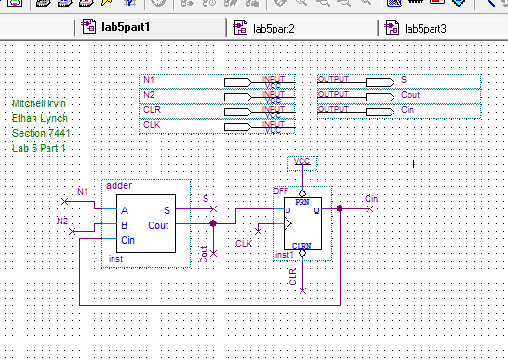

lab5part1.vwf

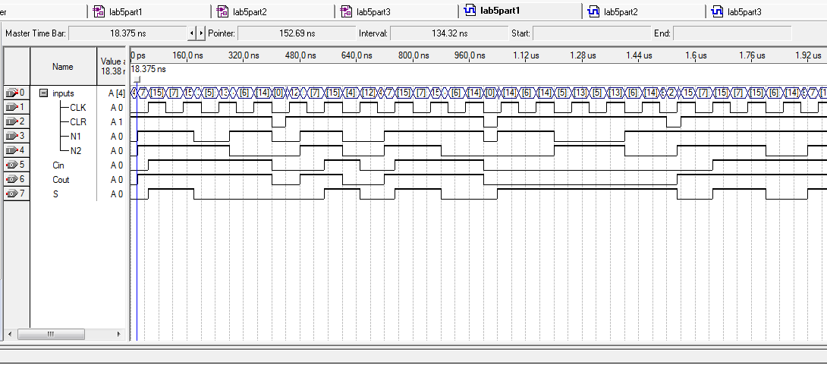

necessary to reset values with clear so that previous values don’t affect new sums

lab5part2.bdf

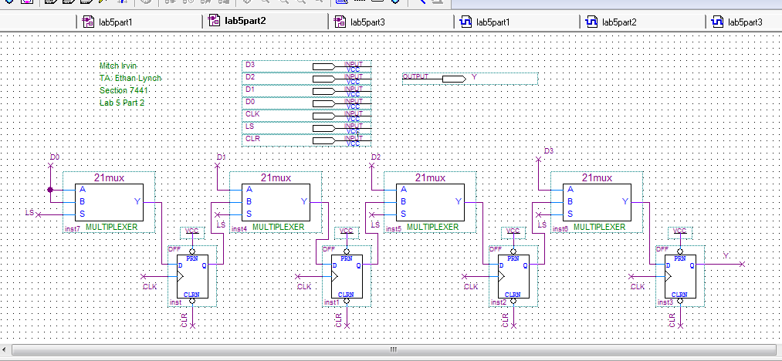

lab5part2.vwf

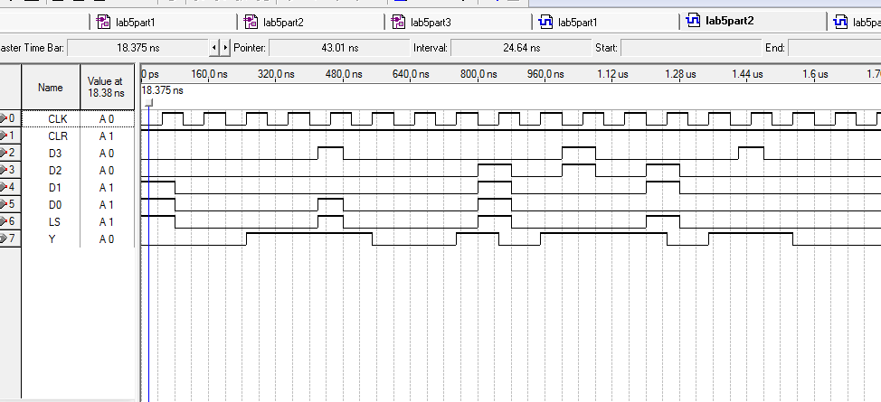

lab5part3.bdf

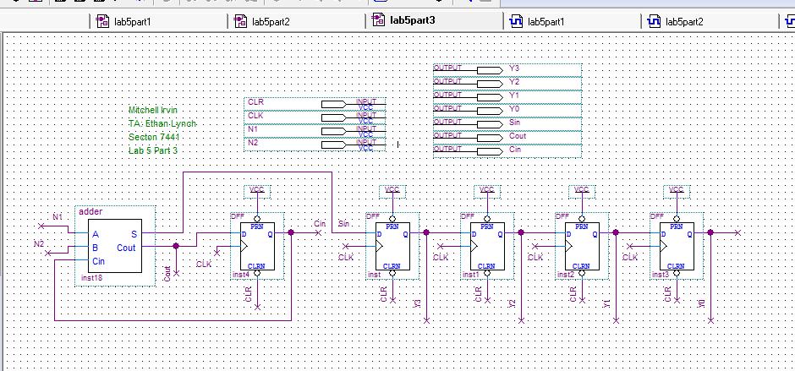

lab5part3.vwf

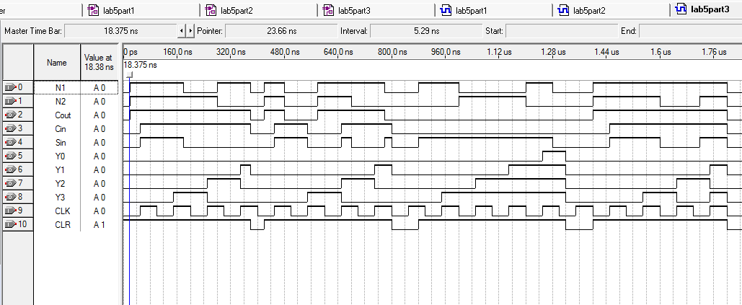

you need a common clock so that everything is being clocked at the same time, if the two devices were being clocked at different times the results could be very flawed.